

**Department of**

**Computer Science and Engineering**

**Lab Report - 01**

Course No.              : CSE-308

Course Title             : System Analysis and Design Laboratory

Submitted By         :

  Name : 1 . Tasmim Sultana(129)

  2 . Fatama Jannat Tisha (131)

                                   3 .  Kamelia Zaman Moon (299)

                               4  .Umma Salma (302)

                                   5 . Sabrina Afrin Toma (304)

         Session        : 2017-18

         Semester     : 3rd year 1st Semester

Date            : 19-07-2020

Submitted To:

Md Musfique Anwar

         Associate Professor, Department of Computer Science and Engineering

         Dr. Md Humayun Kabir

Professor, Department of Computer Science and Engineering

Jahangirnagar University, Savar

**Experiment Number:** 01

**Title:** Activity 1.1 & Activity 1.2

**Objective:**

Activity 1.1: to form a simple team and use a simple “to do” process

Activity 1.2: to develop some experience using the online communication tool slack.

**Procedure:**

Activity 1.1:

Team formation:

1. Team created
2. Team number:

1. Name: Kamelia Zaman Moon – 299

Lab class Date: 01 – 03 -20

Lab class Time: 2:00 pm

Allocated Team Number:

Team Member Details:

Sabrina Afrin -304

Umma Salma -302

Tasmim Sultana -129

Fatama Jannat Tisha -131

4. Sum of age of all members

5. Favourite sports

6. Product of team members’ age

7. Units are studying

8. Favourite food

9. Climb Mount Everest

10. Who is in the team has to travel the greatest distance to university

11. Favourite programming language

The given tasks are completed by following 4 step:

Step 1:“To Do” process

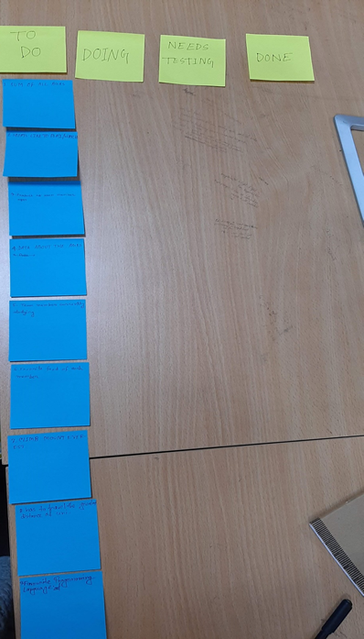

Step 2: Doing

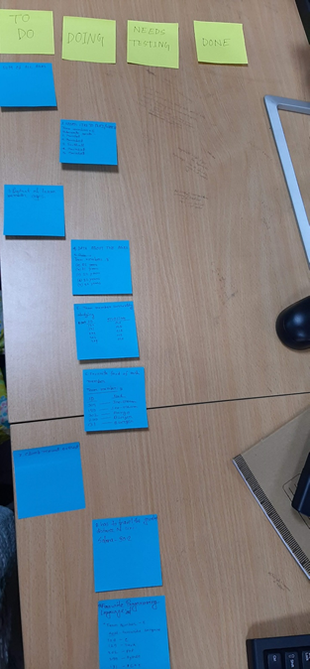

Step 3 & 4: Need Testing and Done

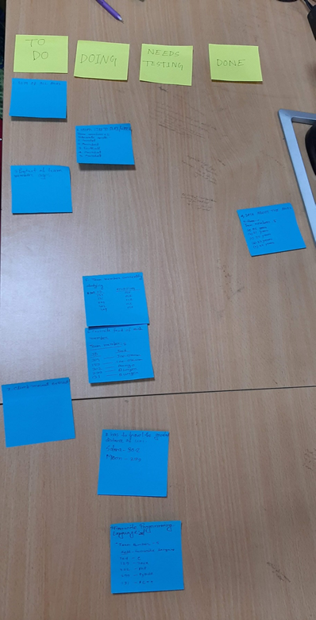



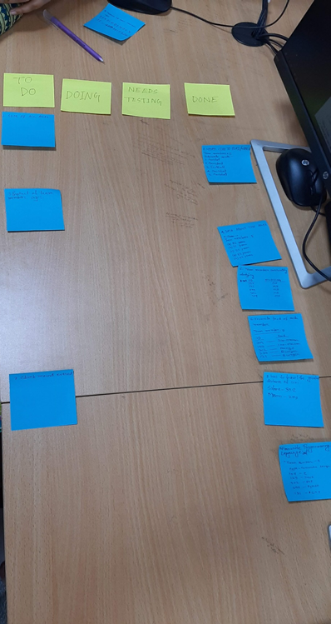

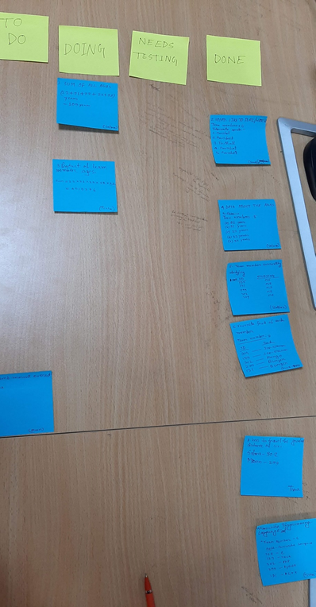

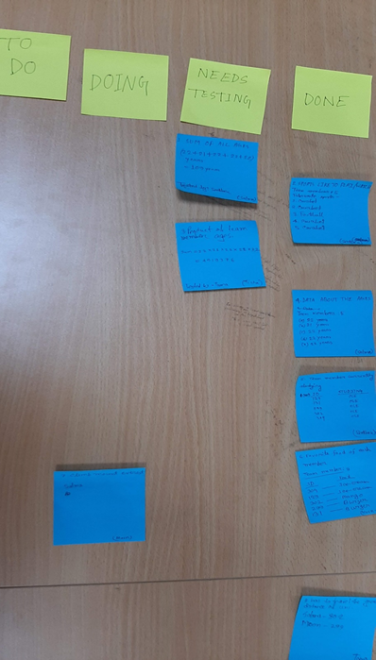

Activity 1.2:

Slack:

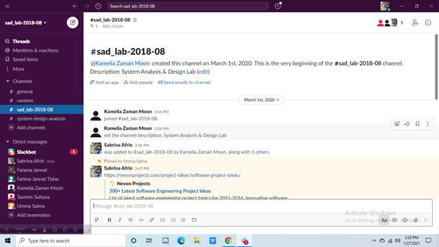

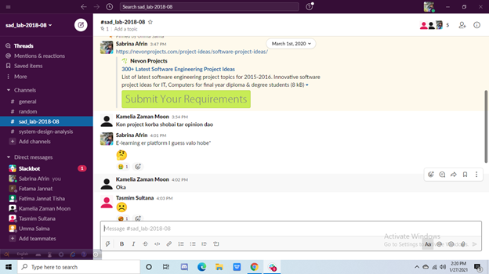

**Discussion:**

Activity 1.1

Any given task can be done in several steps like To Do, Doing, and Need Testing, Done. By following these steps it would be very easy to find errors in projects and make a solution.

Activity 1.2

Slack is a messaging app that almost every workplace group seems to be using .It makes an easy way of communication between the members of a team. From this lab we acknowledged the use of slack that we give us an appropriate way to make an inter-communication between team members.